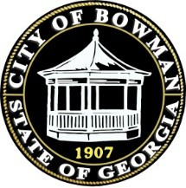

**Agenda Bowman monthly meeting**

**Wednesday January 8th, 2024**

**6:30 pm**

**City Hall**

1. Call to order
2. Prayer
3. Pledge of Allegiance
4. Approval of minutes (November 13th, 2024)
5. Approval of minutes (December 11th,2024)
6. 3rd reading of GMA Retirement Ordinance
7. Vote on updated pricing for the community center
8. Resolution for the upcoming election
9. Gas rate increase
10. Decorum ordinances
11. Mayor Pro tempore position
12. New committee placement
13. Mayor’s Report
14. Council Members Reports
15. Public Works Report
16. Hospital Reports
17. Adjournment